**https://github.com/svermeulen/Zenject**

**Context Types**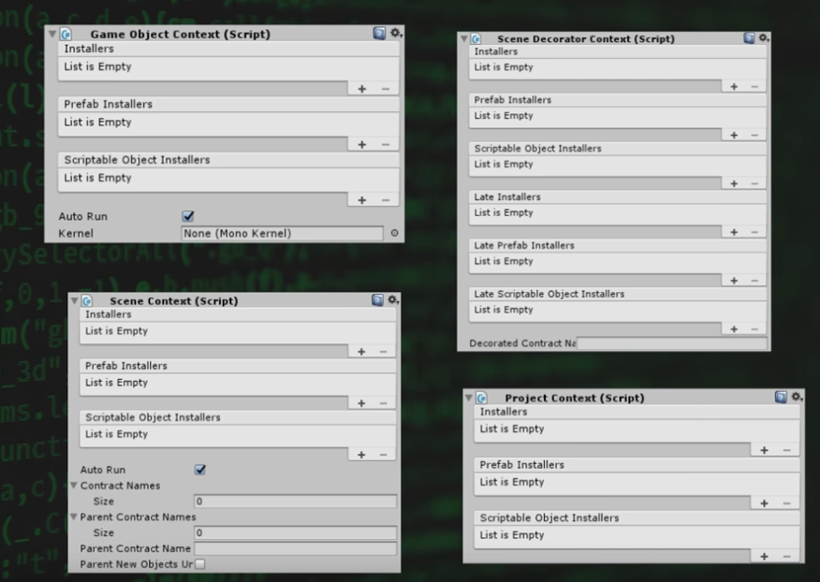

**Zenject Execution Order of Operations**

1. Unity Awake Phase
   1. ProjectContext initialized (Only once) – Global Dependencies, Dependencies Reused every scene
      1. Injectable MonoBehaviours passed into Container
      2. InstallBindings called on each installer
      3. Non-Lazy objects are constructed

**SceneContext and Decorator Context are both initialized at the same time!**

* 1. SceneContext () initialized - Entry point of each scene, Initializes scenes dependencies.
     1. Injectable MonoBehaviours passed into Container
     2. InstallBindings called on each installer
     3. Non-Lazy objects are constructed
  2. Decorator Context
     1. Nested dependencies
     2. Dynamically adds functionality
     3. Share SceneContext Container
  3. GameObjectContexts – Subconteiner Context, Groups dependencies, Multiple instances per scene and uses Facade Pattern
     1. Nested dependencies
     2. Dynamically adds functionality
     3. Share SceneContext Container
     4. Injectable MonoBehaviours passed into Container
     5. InstallBindings called on each installer
     6. Non-Lazy objects are constructed

<https://github.com/svermeulen/Zenject>